**Answer 1.**

**Decision Tree:**

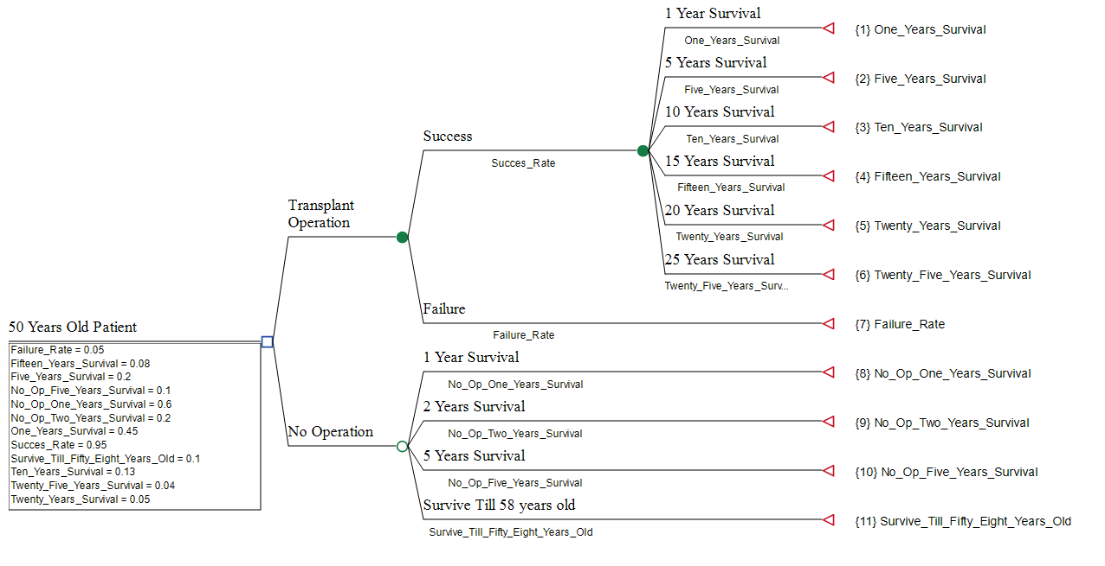

When deciding whether or not to select the transplant operation, building a decision tree can help the patient consider the pros and cons of both options.

For the patient to opt for the transplant operation, there must be a greater benefit than the risk associated with it.

The first branch of the decision tree should consider the risk associated with the transplant operation. There is a 5% chance that the patient will die during the operation or its recovery stage, and a 45% chance that he will die during the first year.

The second branch of the decision tree should consider the benefits associated with the transplant operation. While there is no guarantee of survival, there is a 20% chance of living for 5 years, a 13% chance of living for 10 years, and an 8%, 5%, and 4% chance of living for 15, 20, and 25 years respectively.

The third branch should consider the risk associated with not selecting the transplant operation. There is a 60% chance of living 1 year, a 20% chance of living for 2 years, and a 10% chance of living to age 58.

[**Explanation**](https://www.chegg.com/homework-help/questions-and-answers/50-year-old-patient-diagnosed-decaying-liver-although-healthy-patient-s-liver-problem-coul-q107930948?trackid=f5537fc6dafe&strackid=af18527aafdb#answer-explanation-tabs-for-step-2_tabpanel_0)

Based on the information provided, it appears that the patient should select the transplant operation. Although there is a risk associated with the procedure, it is likely that the patient will have a greater chance of survival if he opts for the transplant operation.

**Answer 2:**

**Other Factors to Consider:**

When considering the transplant operation, the patient should consider other factors in addition to the risks and benefits associated with the procedure.

The patient should take into account his overall health and lifestyle. A healthy patient who is physically active and has a balanced diet may have a greater chance of surviving the operation and recovery phase.

On the other hand, an unhealthy patient with poor nutrition and an inactive lifestyle may have a greater risk of complications and death.

The patient should also consider the cost and availability of the transplant operation. Depending on the patient’s financial and insurance situation, the cost of the operation may be prohibitive.

The patient should also consider the availability of the procedure, as it may not be available in his area. The patient should also consider the emotional and psychological toll of the operation.

[**Explanation**](https://www.chegg.com/homework-help/questions-and-answers/50-year-old-patient-diagnosed-decaying-liver-although-healthy-patient-s-liver-problem-coul-q107930948?trackid=f5537fc6dafe&strackid=af18527aafdb#answer-explanation-tabs-for-step-3_tabpanel_0)

The patient should consider the amount of support he will have during the recovery period, and whether or not he is emotionally and mentally prepared for the operation and recovery.

Finally, the patient should consider the advice of his doctor. His doctor may have insight into the patient’s health, lifestyle, and overall wellbeing that will help him make an informed decision.

**Answer 3.**

**Additional Treatment Possibility:**

In addition to the transplant operation, the patient may consider other treatments for his decaying liver.

One option is to undergo a liver resection, which is a procedure that removes the portion of the liver that is affected by the disease. This procedure has a mortality rate of 1-5%, and a reported 5-year survival rate of up to 75%.

The patient may also consider a liver transplantation with a living donor. This procedure has a mortality rate of 1-2%, and a reported 5-year survival rate of up to 85%. The patient may also consider an alternative treatment option, such as a liver transplantation with an artificial liver support system.

This system is designed to provide temporary liver support for patients until they can receive a transplant. The mortality rate associated with this procedure is not yet known, but studies have shown that it can provide a bridge to recovery in some cases.

**The final decision**

Finally, the patient may consider a liver transplantation with a deceased donor. This procedure has a mortality rate of up to 5%, and a reported 5-year survival rate of up to 80%. Ultimately, the patient should discuss all of his treatment options with his doctor and make an informed decision based on the risks and benefits associated with each procedure.